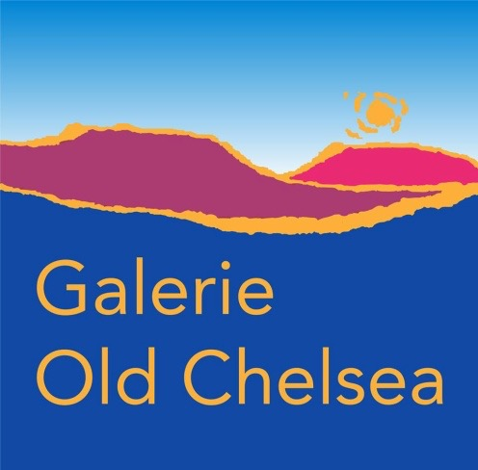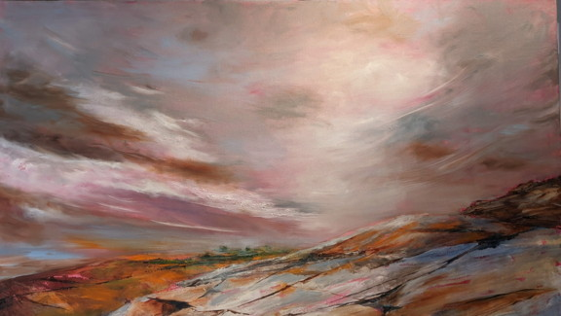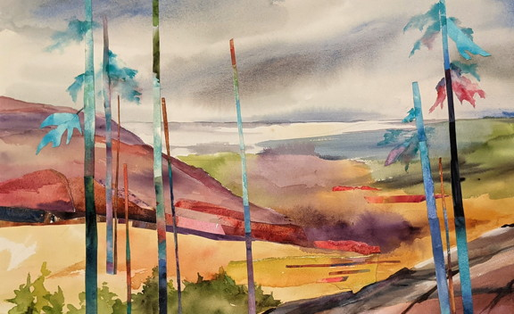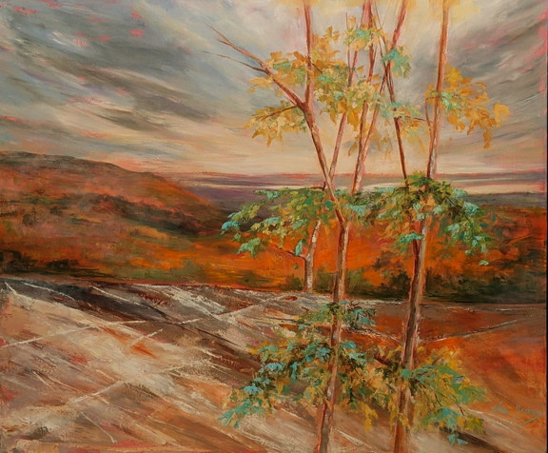
De Lina Yachnin : Breathtaking Autumn Colours A Gatineau Moment

FOR IMMEDIATE RELEASE

“Connecté” by Lina Yachnin

Galerie Old Chelsea, Chelsea, Quebec
October 16 to Nov. 2, 2025, Wednesday to Saturday - noon to 6 pm; Sunday - noon to 5 pm
Vernissage: Saturday October 18, 1 to 4 pm
The artist will also be present on Oct. 24, 25, 26 and Nov. 1
In “Connecté” a new body of work in both oil and watercolour, the artist invites viewers on a visual journey that bridges the realms of nature and memory. Through layered compositions and evocative forms, the exhibition explores how fragments—both visual and emotional—can coalesce into landscapes and florals that feel both familiar and imagined.
Painting in watercolour becomes a meditative process of layering and discovery. Delicate fragments are seamlessly integrated into each piece, culminating in cohesive scenes that resonate with emotion and place. These works invite the viewer to reflect on how natural environments are often experienced as a tapestry of memory, perception, and imagination.
This layered approach carries into the artist’s oil paintings, where bold colour and dynamic forms shift the ordinary into the extraordinary. Each canvas is built with intentional depth, drawing the eye into scenes that are at once grounded and surreal.
With “Connecté,” the Lina Yachnin offers more than just images of nature—the exhibition becomes a space where personal and collective memory intersect with the natural world.
We invite you to come and enjoy the journey with the artist.
Galerie Old Chelsea is a collective of regional artists located in the beautiful Gatineau Hills above award-winning Les Fougères restaurant situated at 783 route 105, Chelsea, Québec, J9B1P1.

www.galerieoldchelsea.ca; Facebook: Galerie Old Chelsea (on Route 105, not on Scott) & Instagram
For information contact Anne Swiderski at 819 827 8504 swiderski.anne@gmail.com or if unavailable, Marianne Feaver at esdfeav@hotmail.com 613 748 7528.

